,

# Project: COVID-19 Data Analysis using IBM Cognos

## Problem Statement

The project aims to analyze COVID-19 cases and deaths data within the European Union and European Economic Area (EU/EEA). Specifically, the goal is to compare and contrast the mean values and standard deviations of daily COVID-19 cases and associated deaths across different countries in the EU/EEA. This analysis will provide insights into the variation of COVID-19 spread and its impact on mortality within this region.

## Understanding the Problem

To successfully accomplish this project, we need to:

1. Define Analysis Objectives:
   * Calculate and compare mean values of daily COVID-19 cases and deaths.
   * Determine the standard deviations to understand the data variability.
   * Visualize the data for easy interpretation and communication of insights.
2. Collect COVID-19 Data:
   * Identify reliable sources for daily COVID-19 cases and deaths data for EU/EEA countries.
   * Ensure data integrity and consistency by verifying sources.
3. Design Relevant Visualizations in IBM Cognos:
   * Create appropriate charts and graphs to represent the data.
   * Choose visualization types that best convey the key insights.
   * Ensure that visualizations are user-friendly and insightful.
4. Derive Insights from the Data:
   * Analyze the visualized data to identify trends and patterns.
   * Highlight variations in COVID-19 cases and deaths.
   * Identify potential factors contributing to these variations.

## Proposed Approach

### Data Collection and Preparation:

* Identify reputable sources such as official health organizations, government reports, or APIs for daily COVID-19 data.
* Gather data for all EU/EEA countries, ensuring consistency and completeness.
* Clean and preprocess the data, handling missing values and outliers.

### Analysis in IBM Cognos:

* Import the cleaned data into IBM Cognos for analysis.
* Create datasets and data modules to facilitate analysis.
* Design relevant visualizations, including line charts, bar charts, and heatmaps.
* Use calculated fields or measures to compute mean values and standard deviations.

### Comparative Analysis:

* Compare and contrast mean daily COVID-19 cases and deaths across EU/EEA countries.
* Use visualizations to highlight variations and trends.
* Consider additional factors such as vaccination rates, population density, and healthcare infrastructure for context.

### Deriving Insights:

* Interpret the visualized data to derive meaningful insights.
* Identify countries with high and low variations in COVID-19 cases and deaths.
* Investigate potential reasons for these variations, considering regional differences and public health measures.

### Documentation and Reporting:

* Prepare a comprehensive report summarizing the analysis.
* Include visualizations, insights, and recommendations.
* Ensure the report is clear and accessible to stakeholders.

Graph:

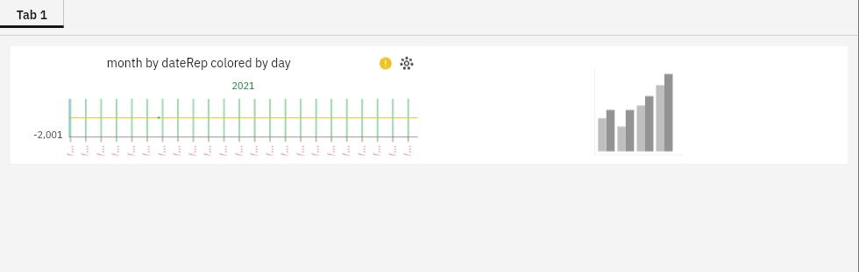

## Conclusion

This document outlines the problem statement, understanding, and proposed approach for the project involving COVID-19 data analysis using IBM Cognos within the EU/EEA. The successful execution of this project will provide valuable insights into the COVID-19 situation in the region, aiding in decision-making and public health efforts.

Feel free to expand or modify this document based on your specific project requirements and available resources. If you have any additional details or questions, please let me know, and I'll be happy to assist further.

This document outlines the problem statement, understanding, and proposed approach for the project involving COVID-19 data analysis using IBM Cognos within the EU/EEA. The successful execution of this project will provide valuable insights into the COVID-19 situation in the region, aiding in decision-making and public health efforts.